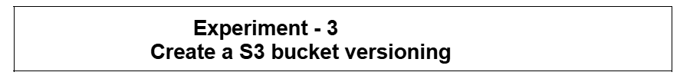
- In console Home, search S3 (Scalable storage in the cloud)
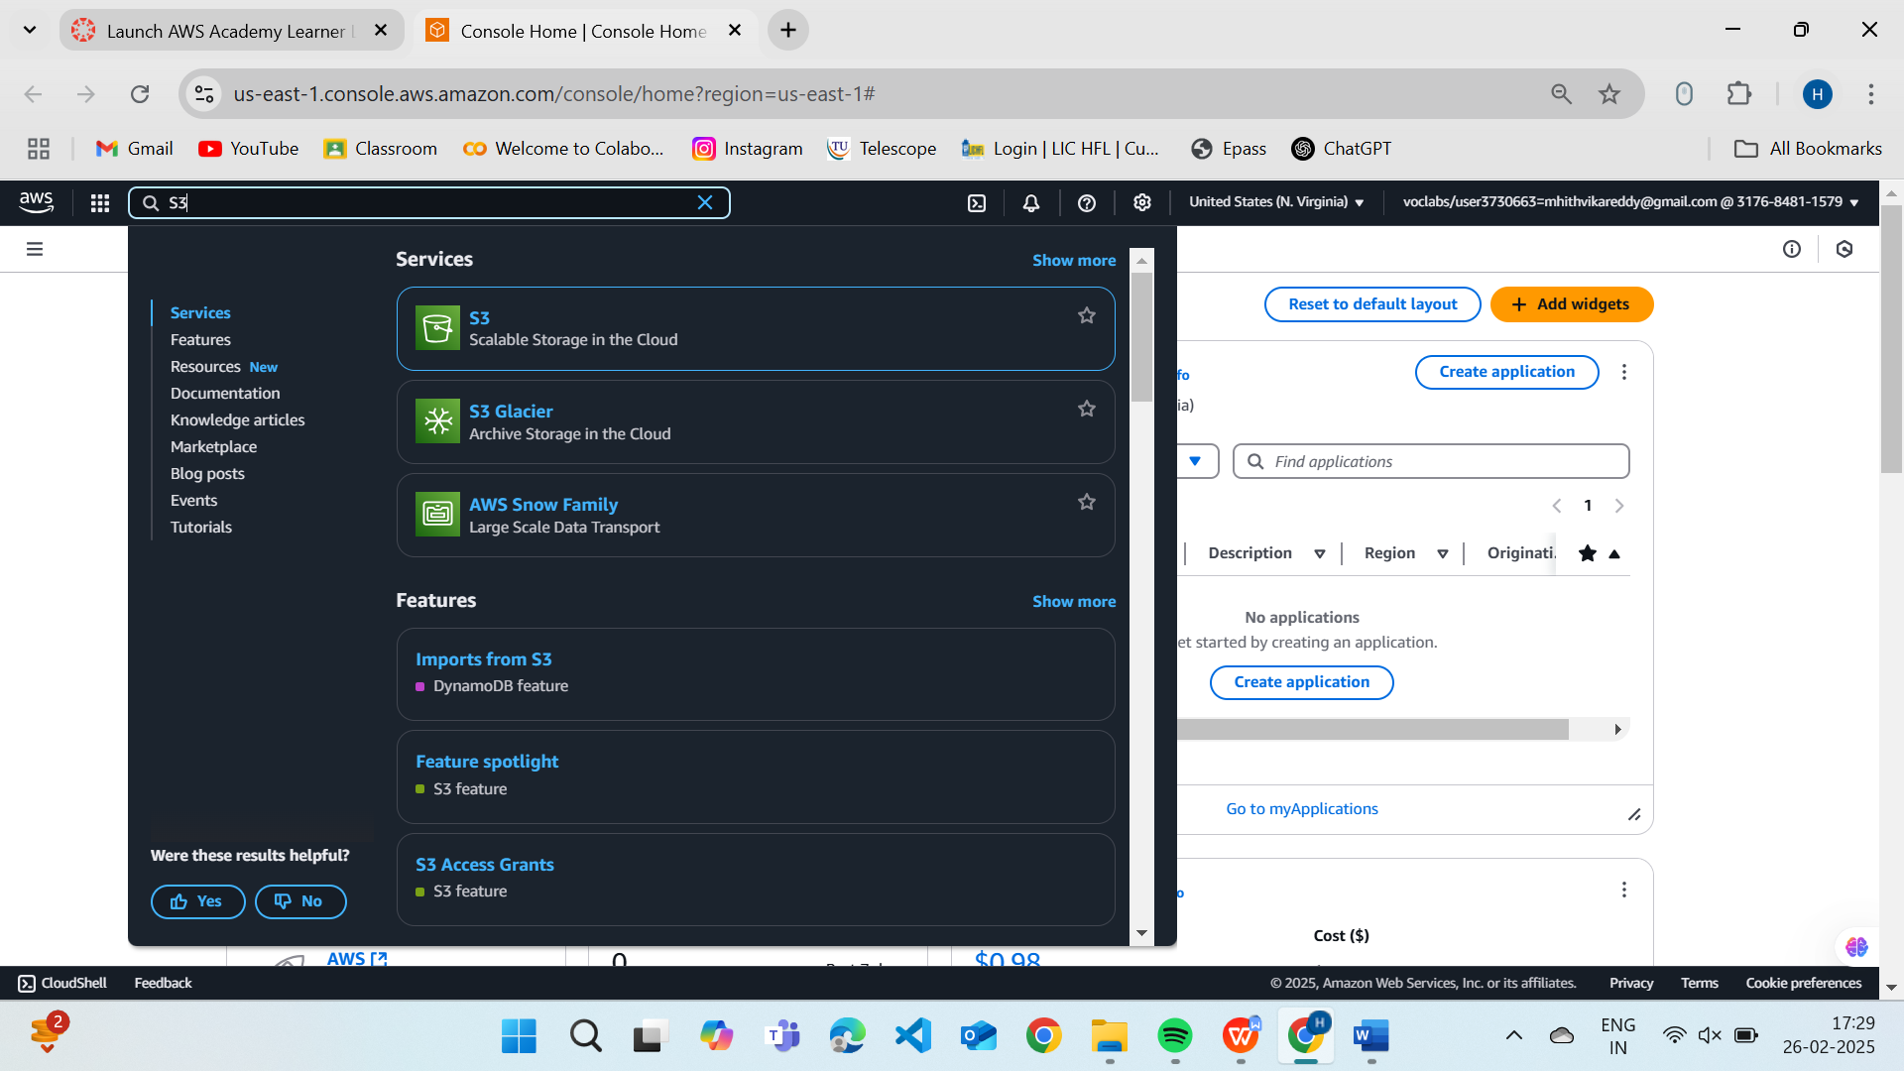
- It will navigate to below page, then click Create a bucket
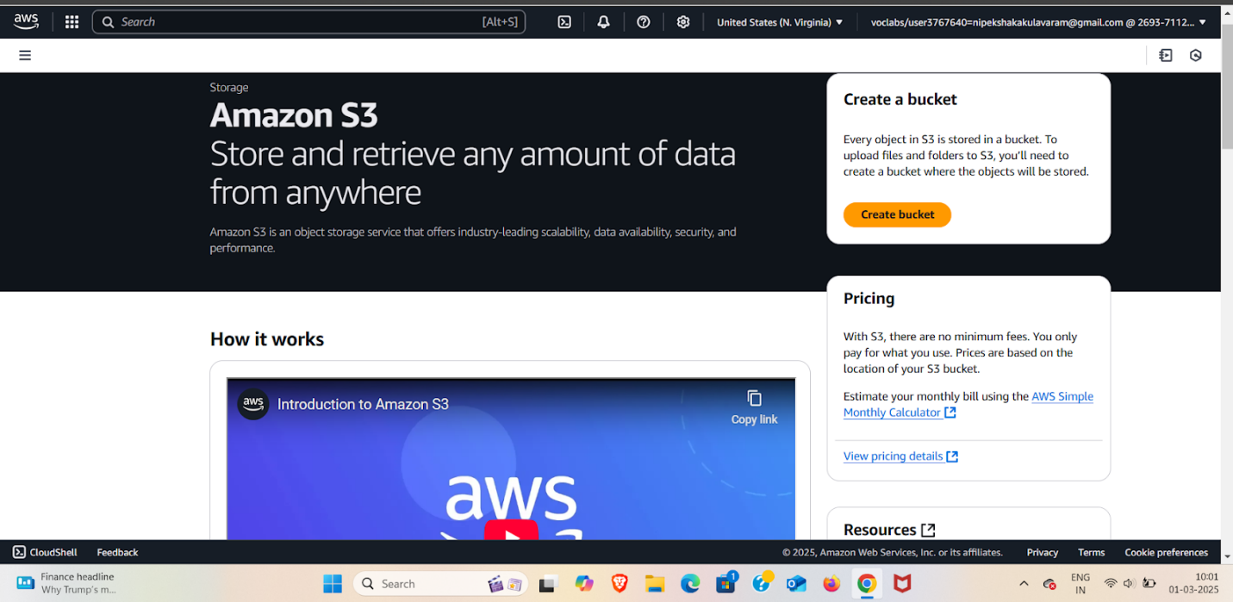

- Create Bucket:
General configuration
Bucket Name: Nipeksha-22bd1a057a
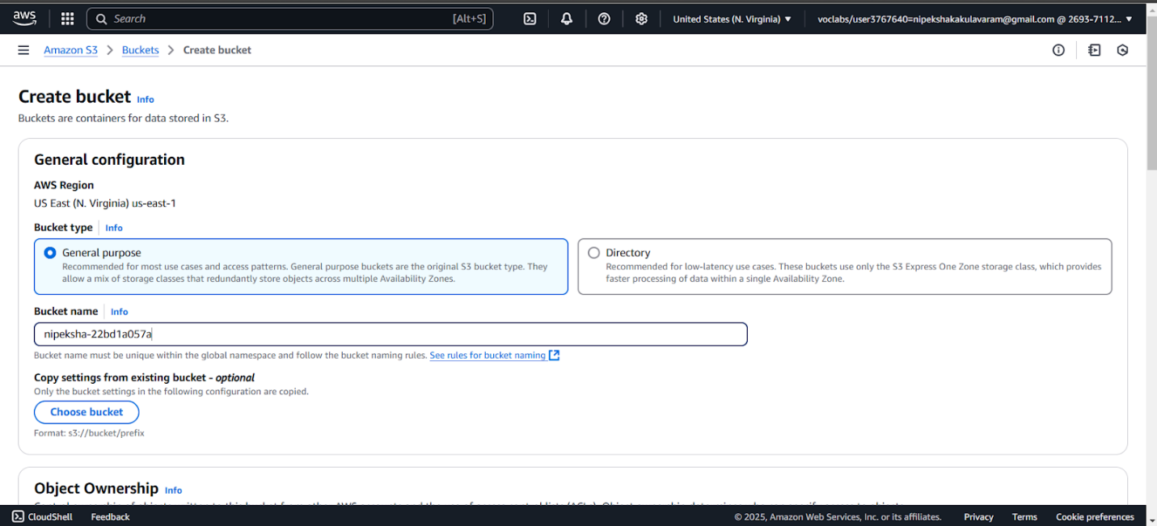
- Choose Object Ownership
- Block Public Access settings for this bucket (disable)
- Bucket Versioning: click to enable
- Tags - optional (0) (Keep default)
- Default encryption
- Encryption type: Server-side encryption with Amazon S3 managed keys (SSE-S3)
- Bucket Key: Enable
- Advanced settings (Keep default)
Finally Click on Create Bucket
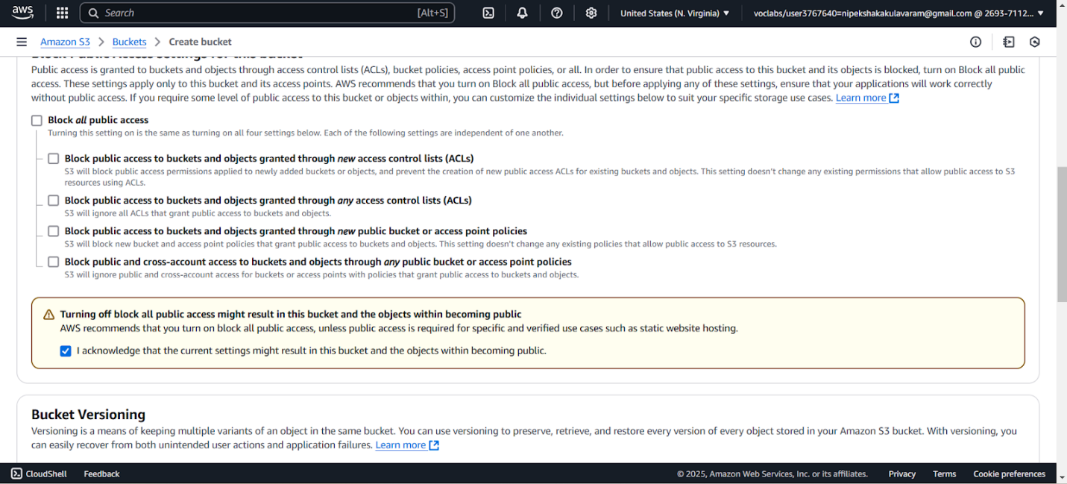

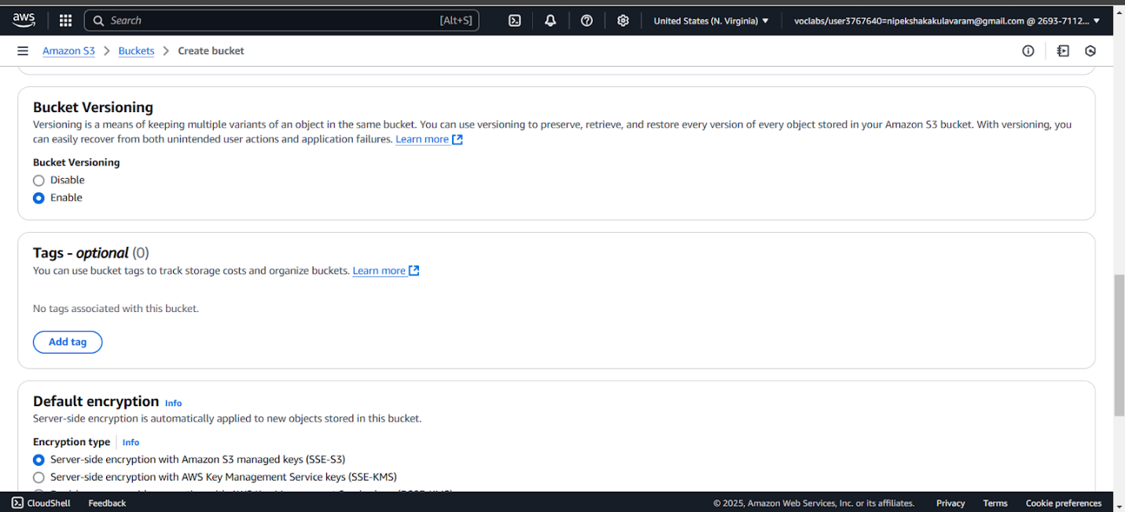
- S3 Bucket Created Successfully with below Image
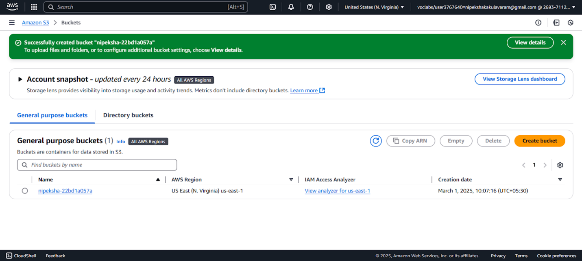
- Click on property tab-> go to bottom you will find Static website hosting click on Edit click & enable
- Static website hosting
- Static website hosting: enable
- Hosting type: Host a static website
- Index document: index.html
- Remaining: default & click save changes
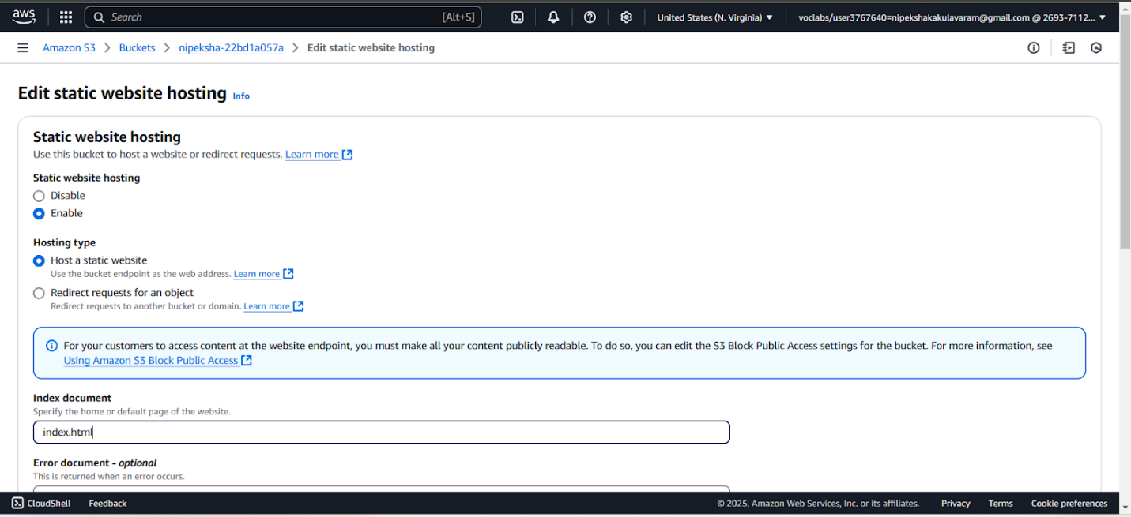

- Scroll down, you will find Bucket Policy: click on edit
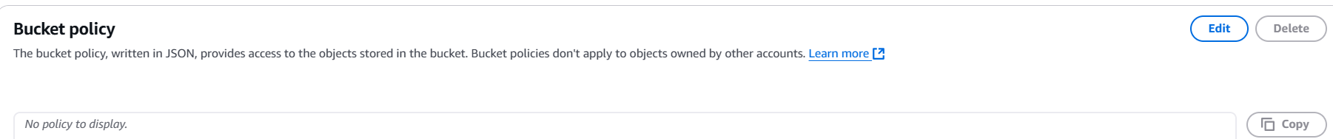
- You will navigate below Image. Now click on Policy generator now you will navigate to other page
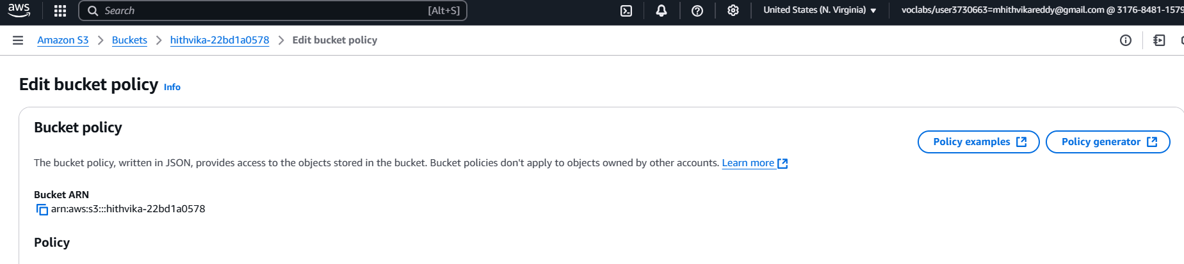
- AWS Policy Generator
- Step 1: Select Policy Type: select S3 Bucket policy
- Step 2: Add Statement(s)
- Principal add: *
- Actions: Get Object (select)
Amazon Resource Name (ARN): go back previous tab & Copy ARN and paste ARN
Example: arn:aws:s3:::hithvika-22bd1a0578
Click Add statement
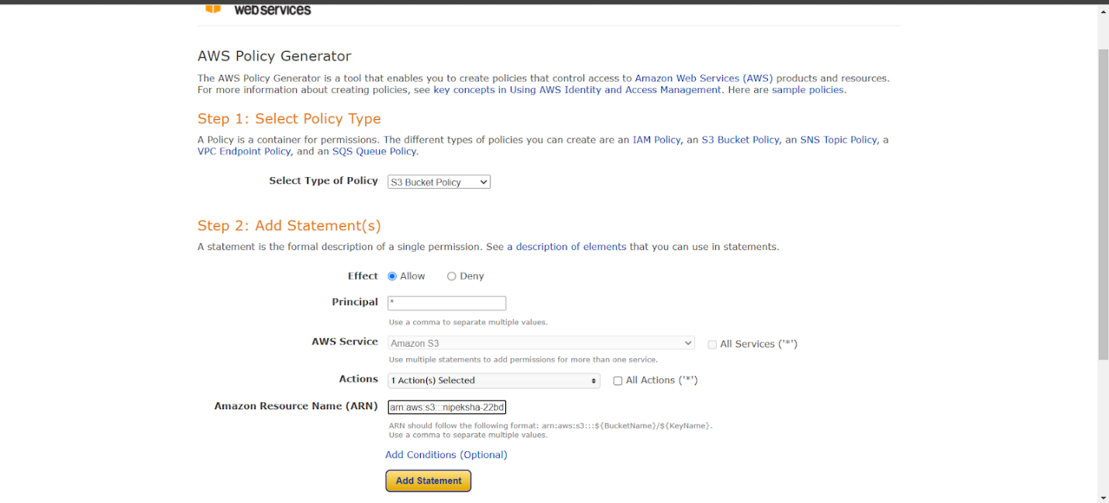

- Click generate policy: copy the JSON Format (sample shown below)
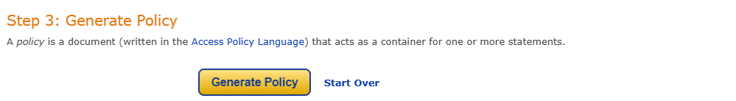
- Now copied JSON Format as to paste in policy
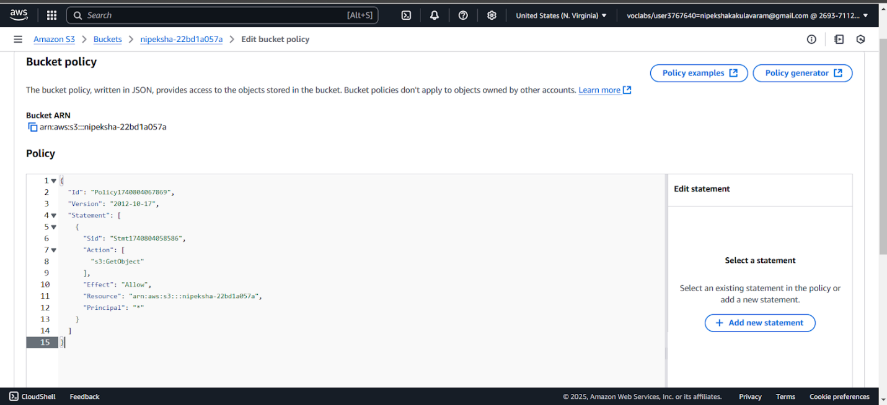

- Line no 11 Resource: add /*
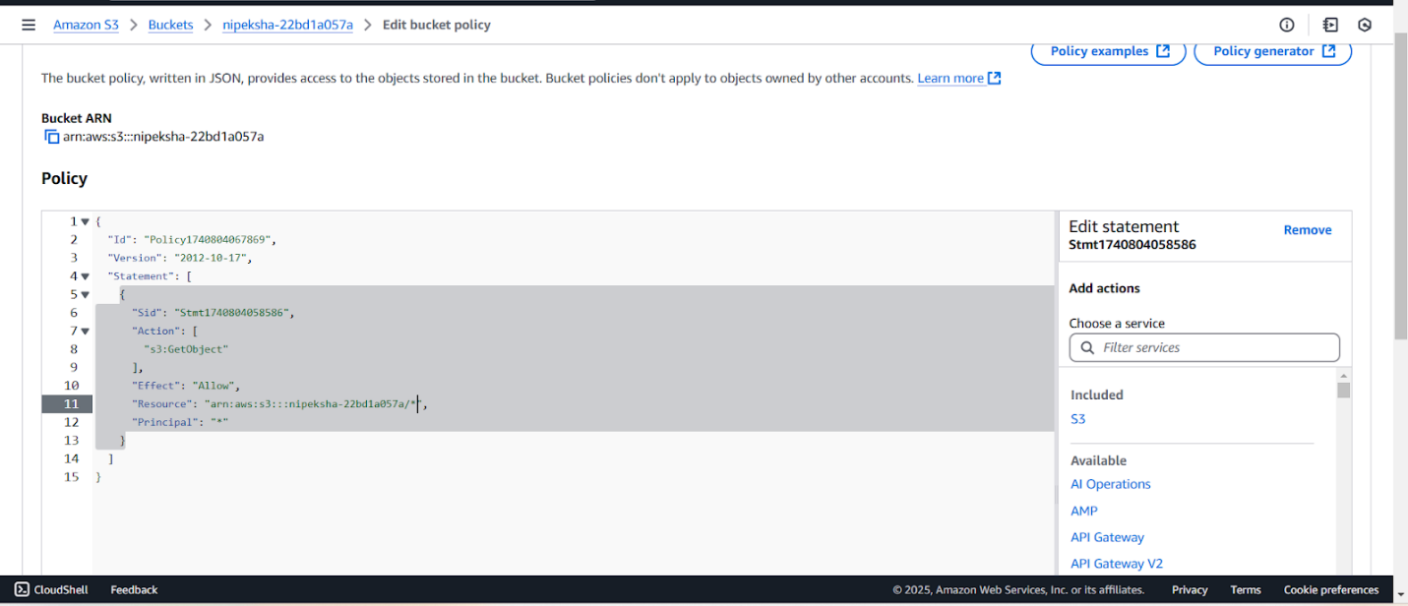

- Simply click & save the changes
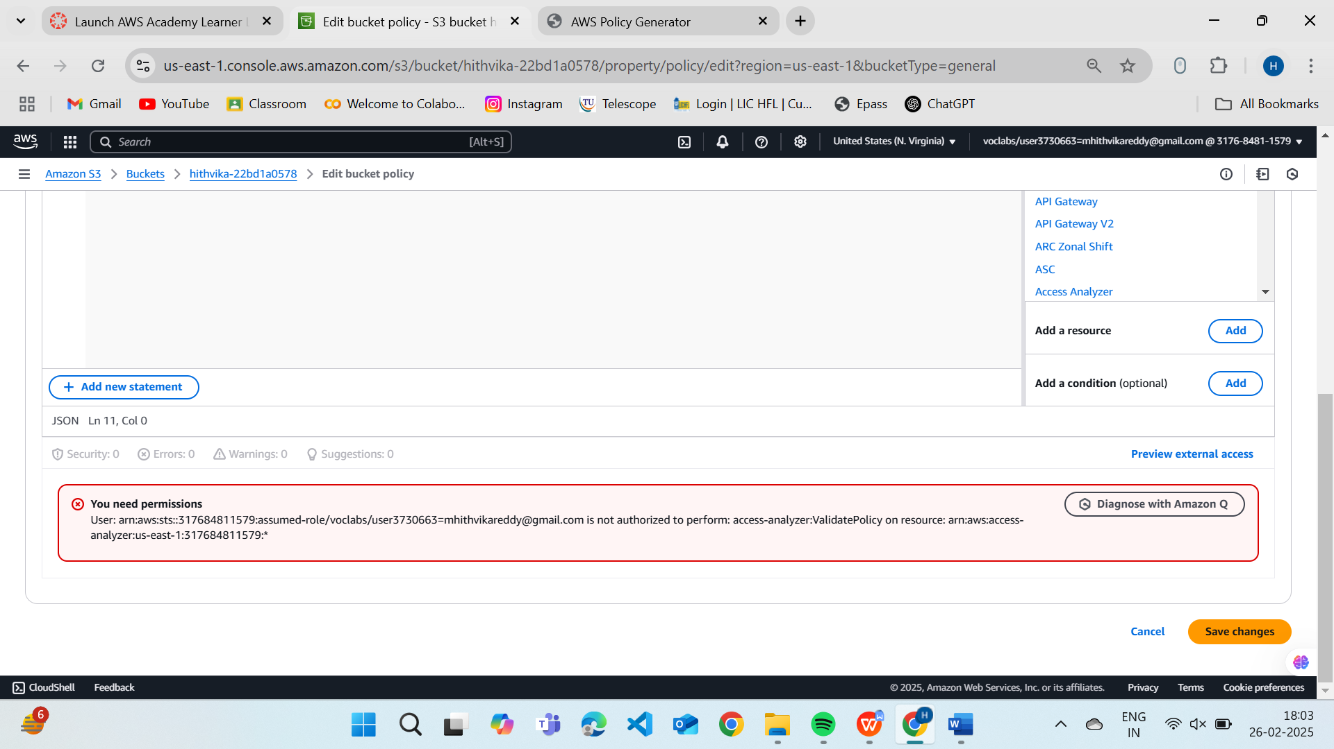
- Upload File1.png (KMIT logo with your name(Nipeksha K) & roll number(22BD1A057A))

Click "Upload" → "Add Files"
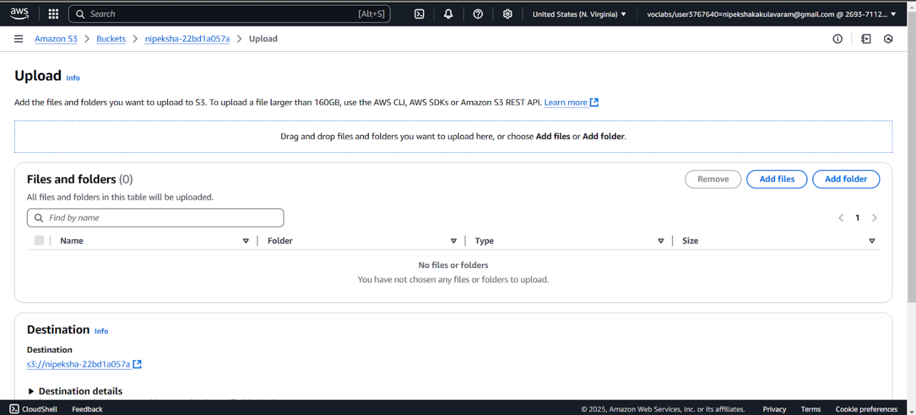
Select File1.png (contains KMIT logo, your name (Nipeksha K) & roll number(22BD1A057A))
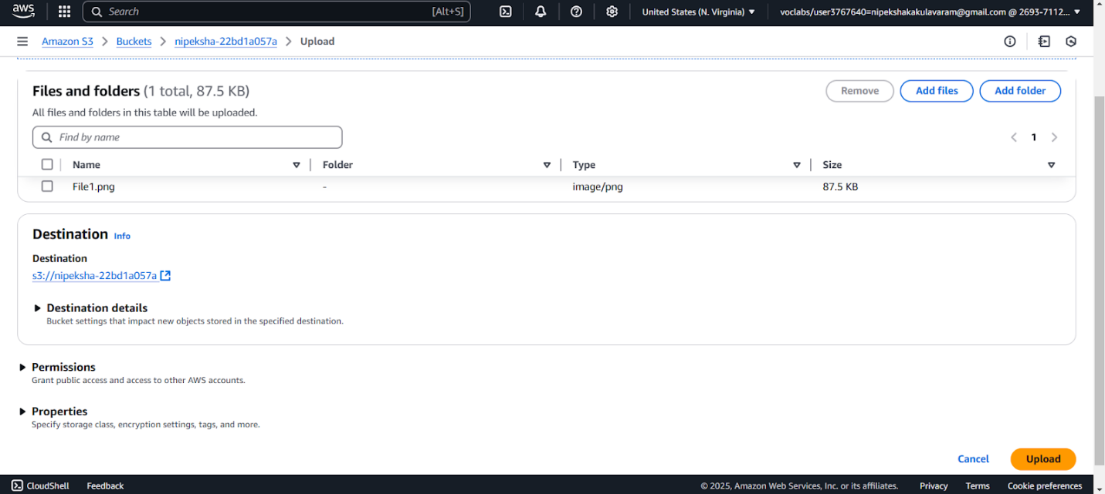
- Click on upload you will get below uploaded Information
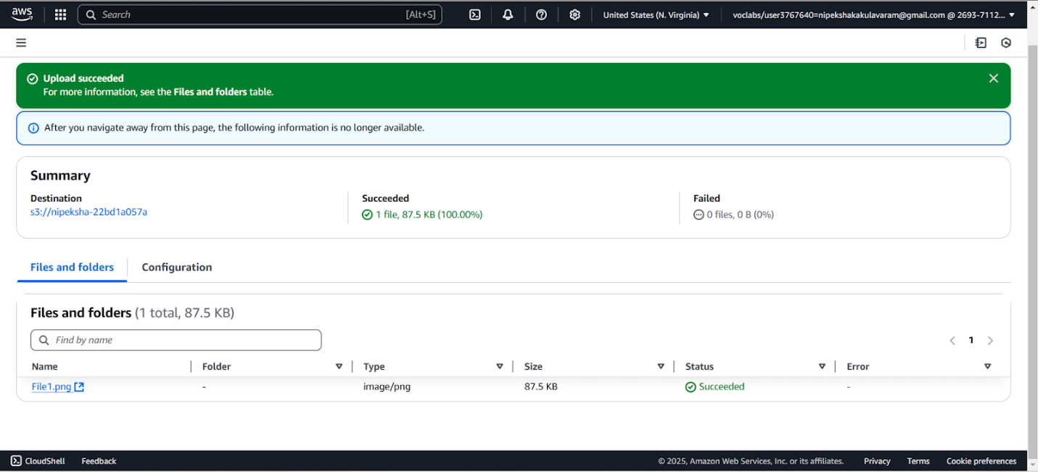
- Now you need to find URL
  - Go to File1.jpg
  - You will find URL i.e http://nipeksha-22bd1a057A.s3.us-east-1.amazonaws.com/File1.jpg
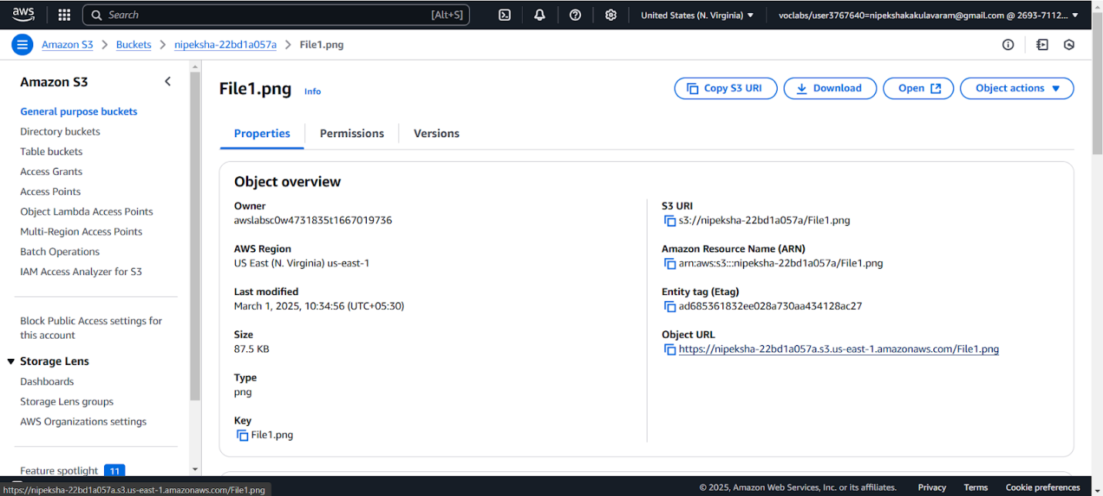

- Navigate to the URL and check File1.png. The following is displayed
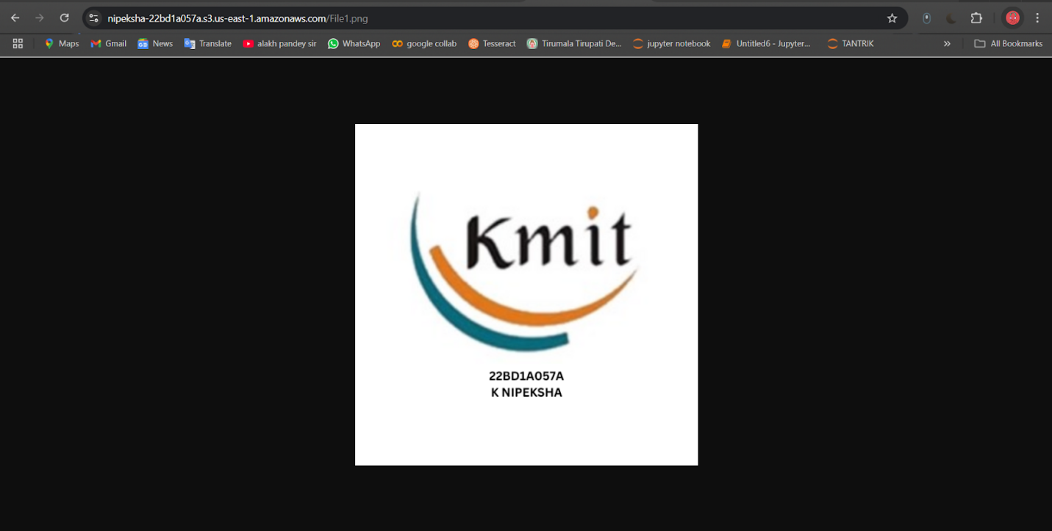

- Upload the new version of File1.png with KMIT logo with full form & location.

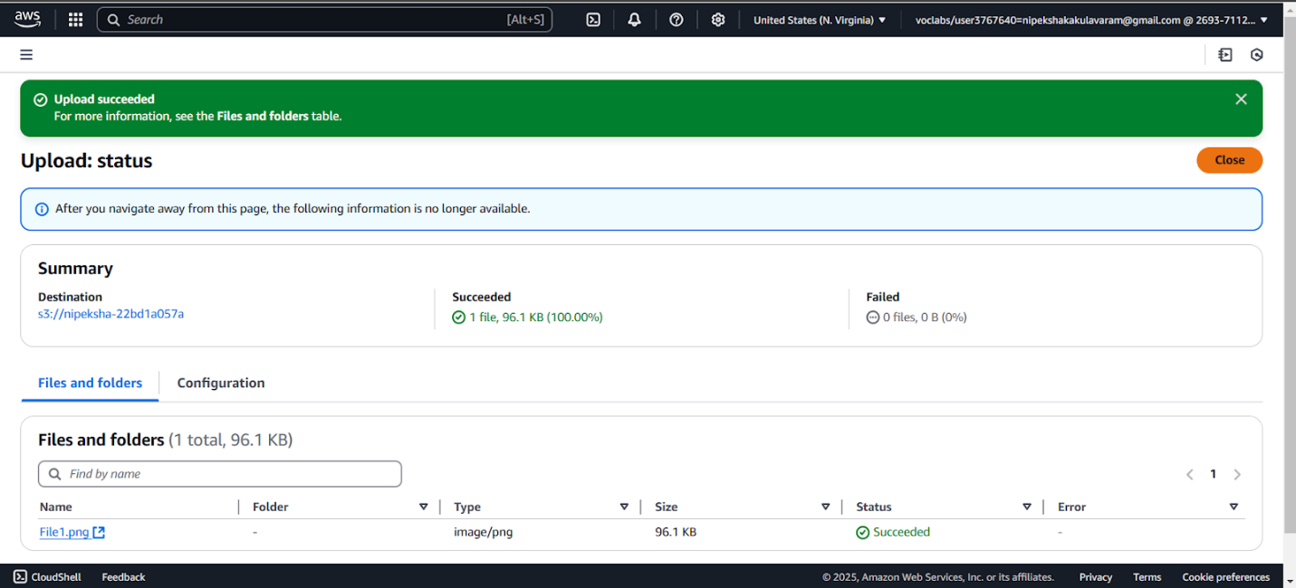

- Now Display the File1.png.
Which File1.png Will Display?
The latest uploaded file (KMIT logo with full form & location) will be displayed.
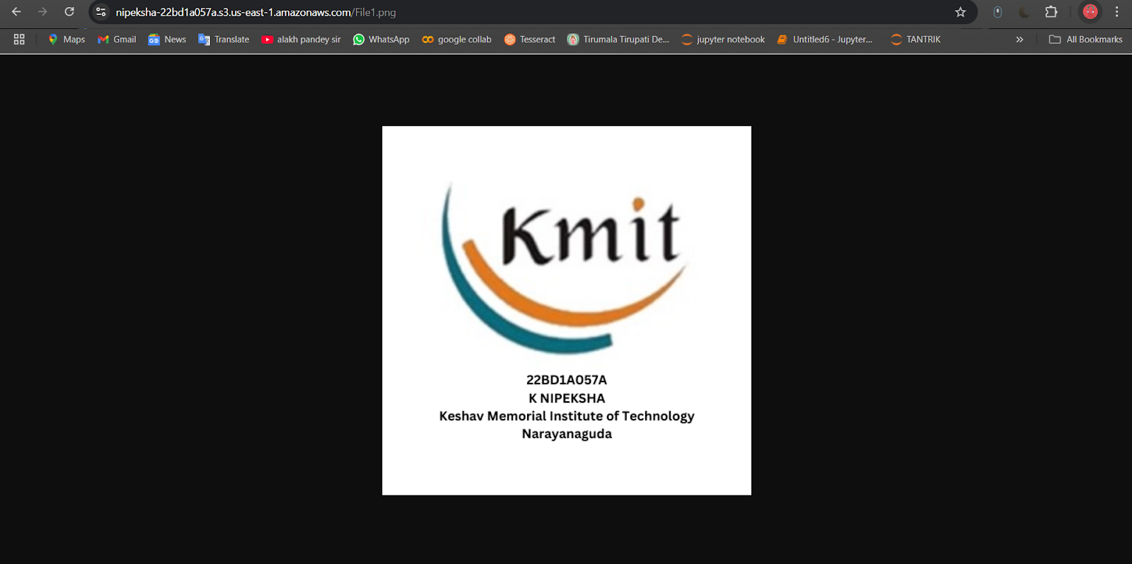

- Upload More Versions of File1.png
Repeat the upload process with different versions:
3rd upload → KMIT & NGIT logos
4th upload → KMIT, NGIT & KMECS logos
5th upload → KMIT, NGIT, KMECS & KMCES logos

3rd upload: KMIT, NGIT logo
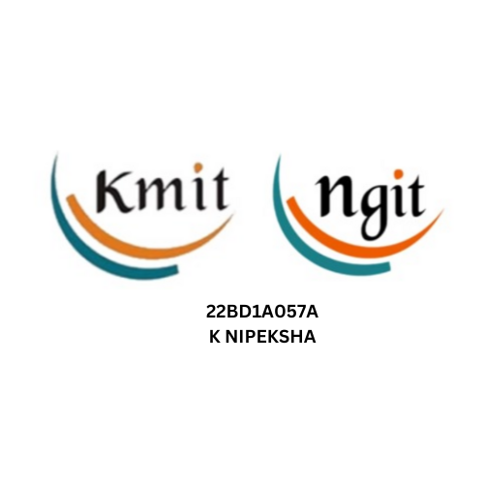
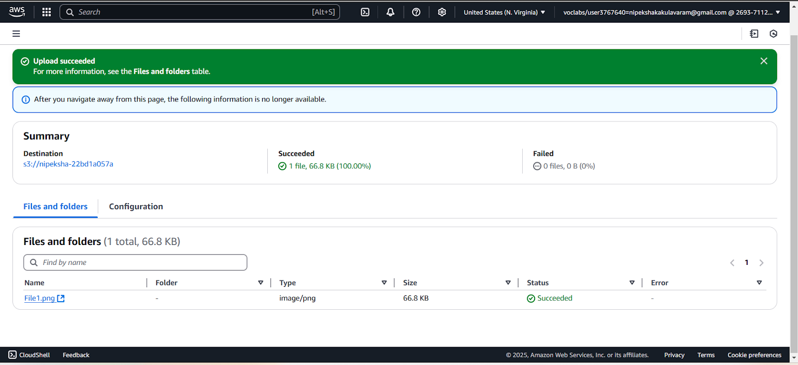

4th upload: KMIT, NGIT, KMEC logo
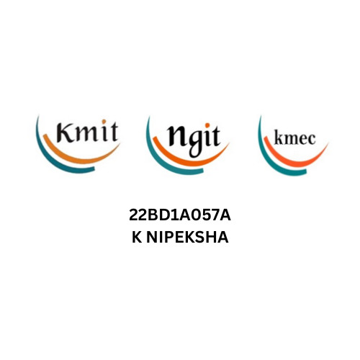
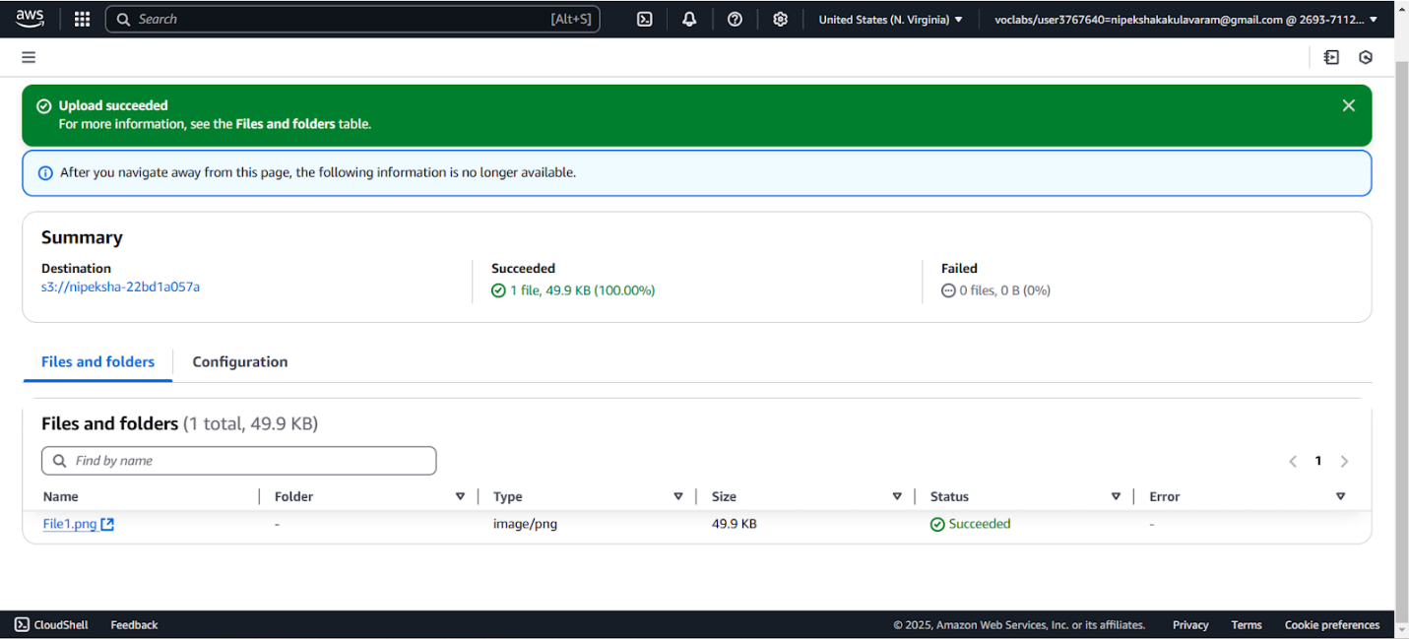
5th upload: KMIT, NGIT, KMECS & KMCES logos
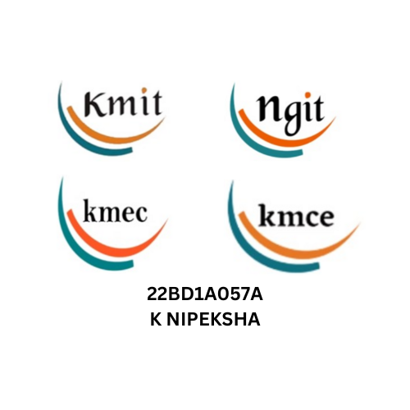

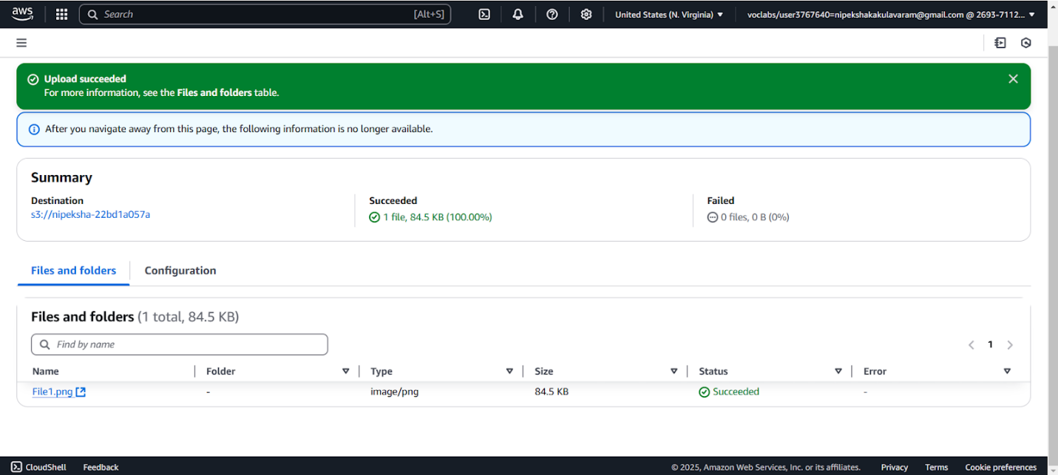

- Which File1.png Will Display?
The most recent version (KMIT, NGIT, KMECS, KMCES logos) will be displayed.
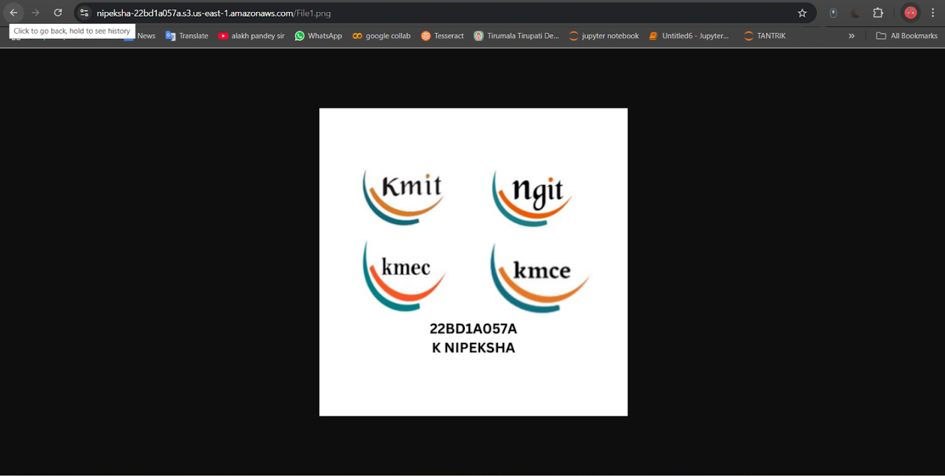

- Retrieve a Specific Version of File1.png
To view the 6th point image (KMIT and NGIT logo image):
Open S3 Bucket → Objects
Click on File1.png
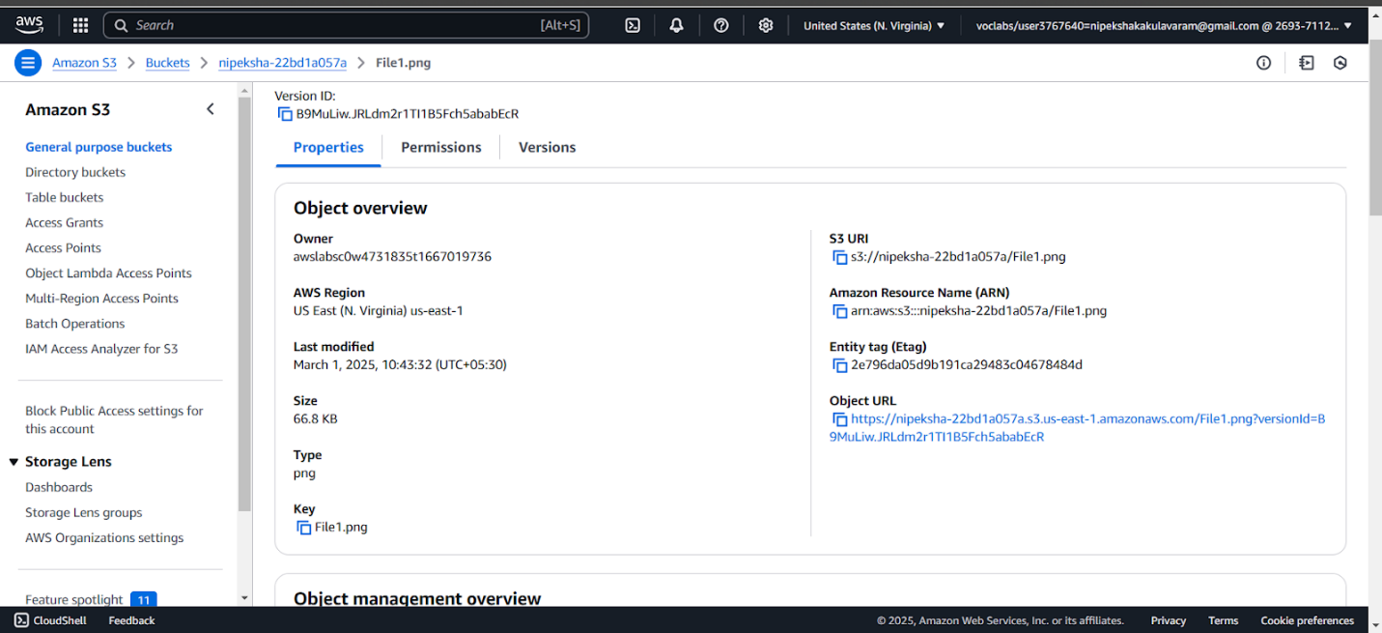

- Click "Versions"
A list of versions will appear.
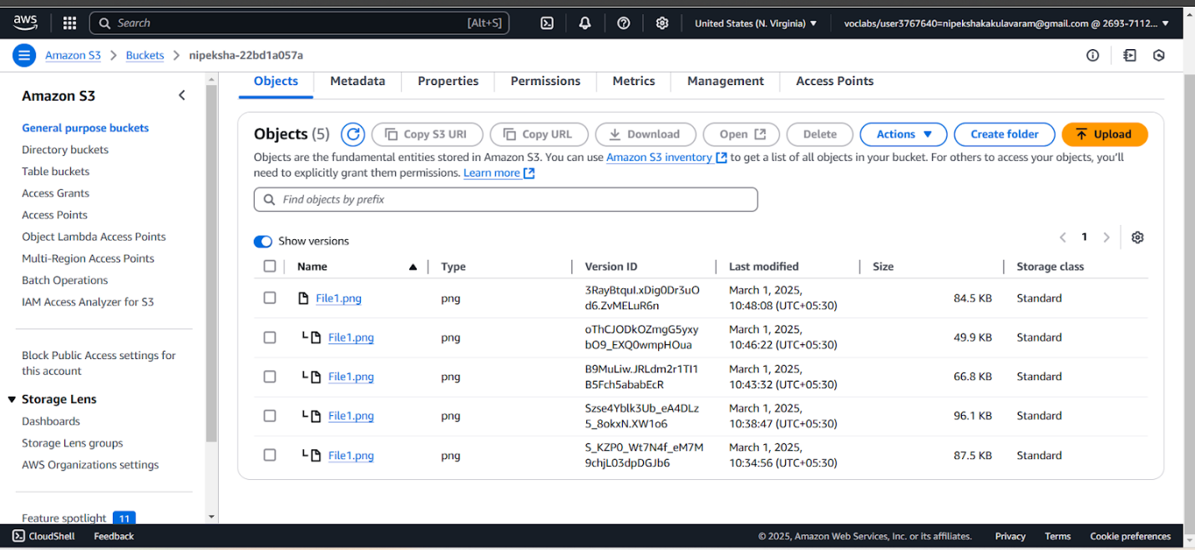
- Select the needed version. Select the image and open it.
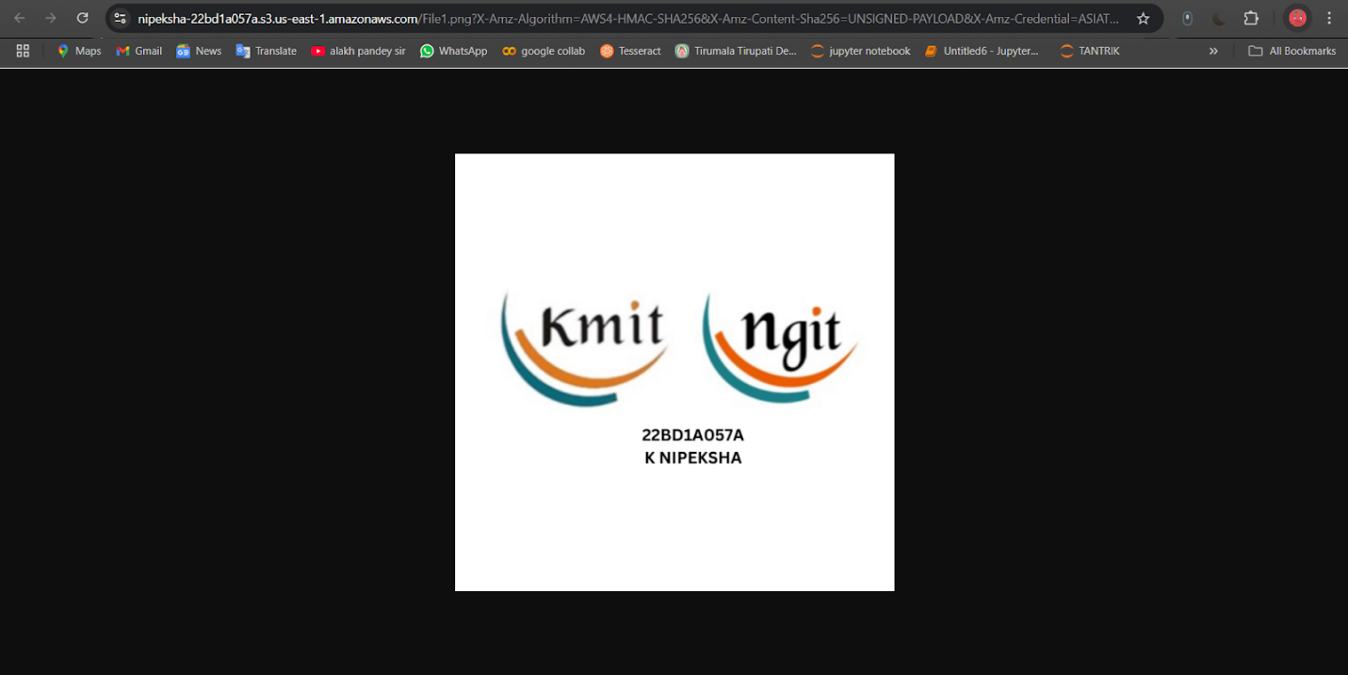

- Delete
- Go to S3 Bucket → Objects
- Click on File1.png
- Select the object to delete.
- Click "Delete"
This only marks the object as deleted, but the old versions are still retrievable.
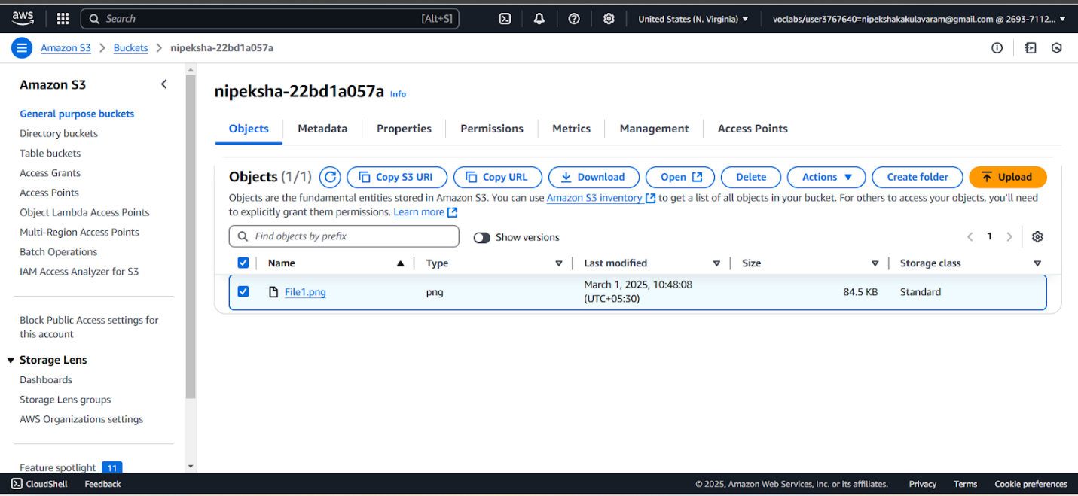
- Type delete → delete objects
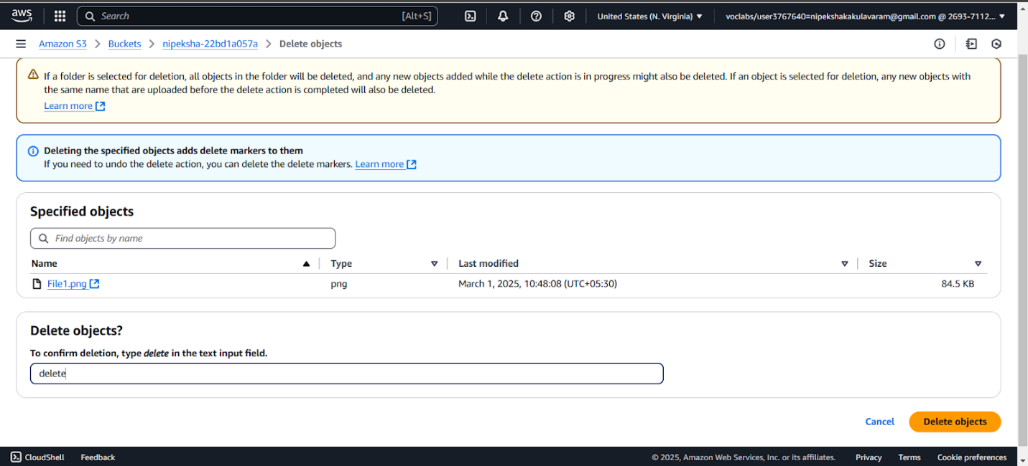

- Restore a Deleted Image
- Go to S3 Bucket → Objects
- Click "Show versions"
- Look for the deleted file (it will have a "Delete Marker").
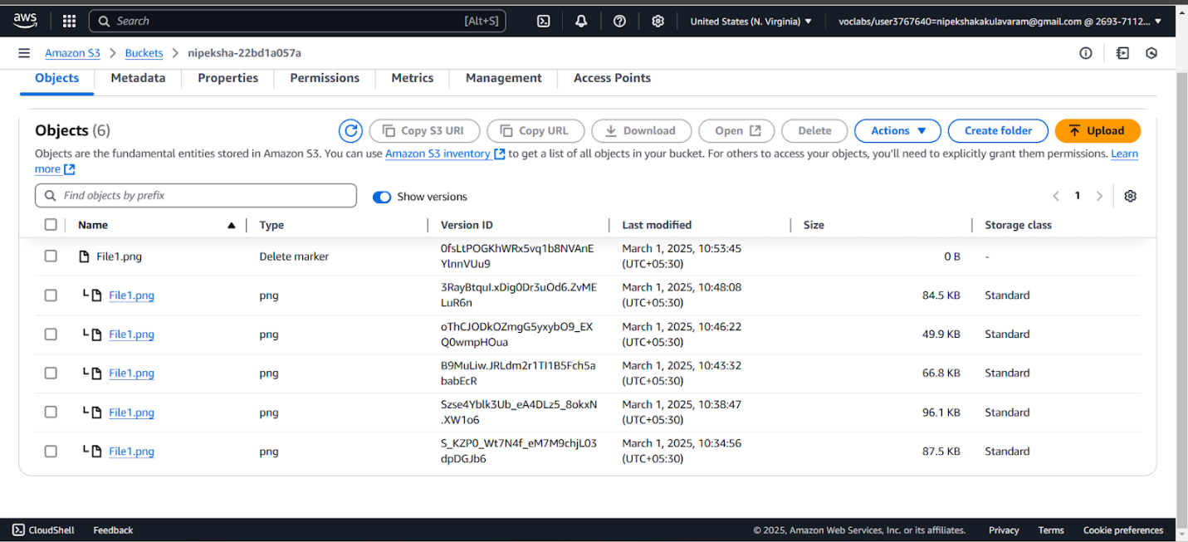

- Delete the marker
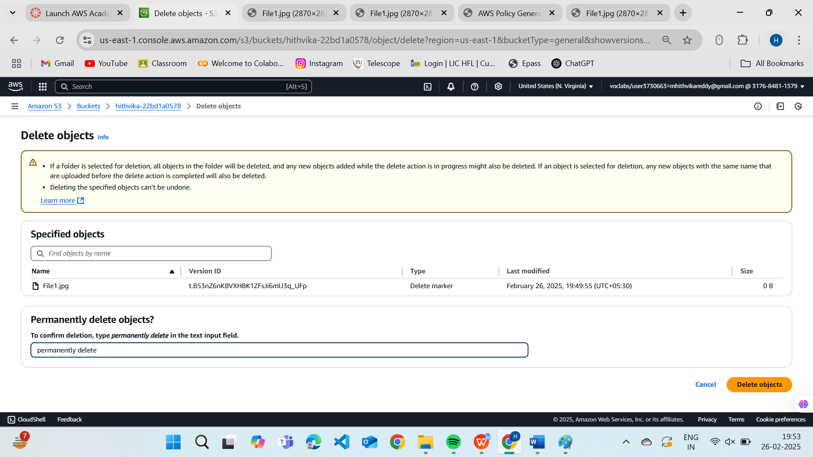

- Successfully delete Objects.
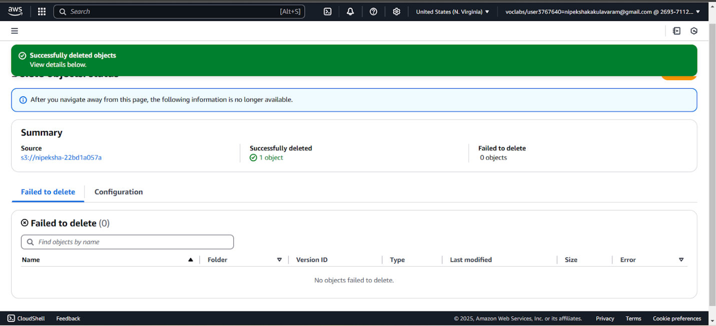

- These are the available versions for now.
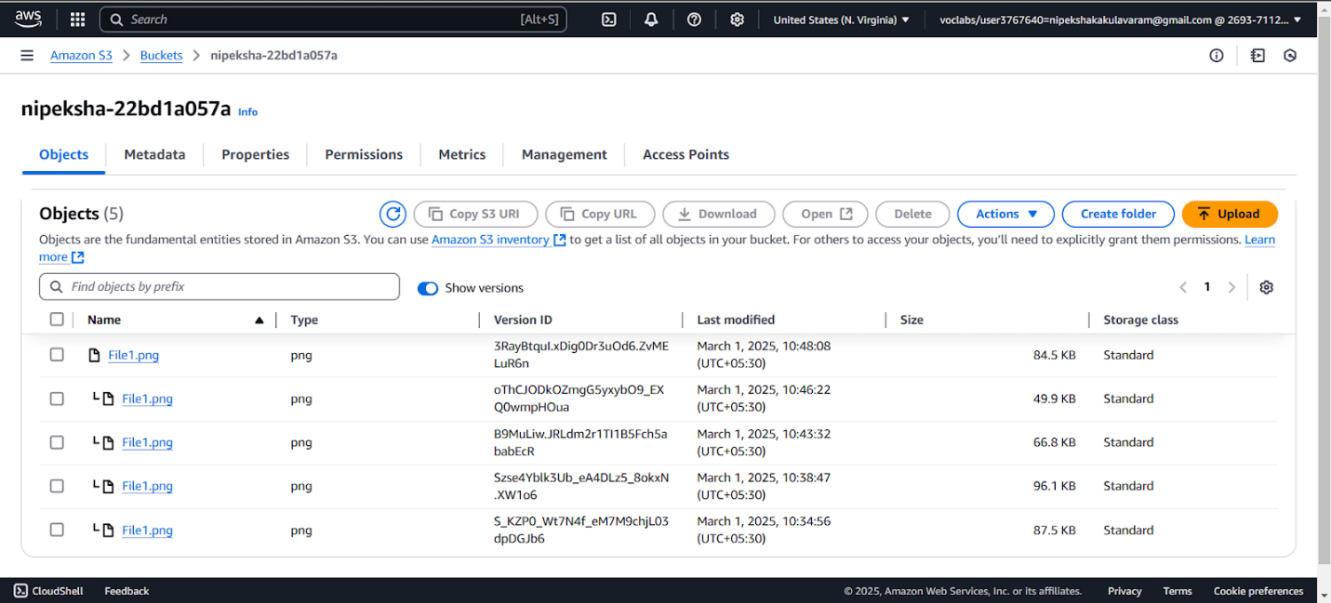

- Now, the previous version of the file is restored and will be visible again.
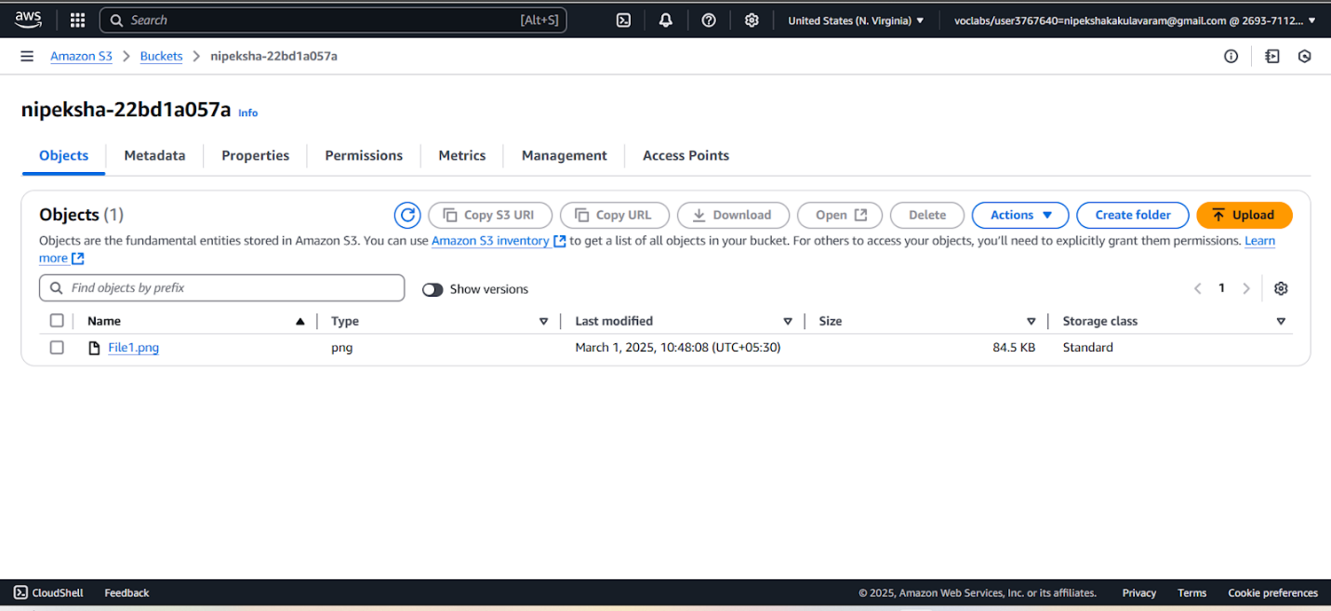
Opening the URL:
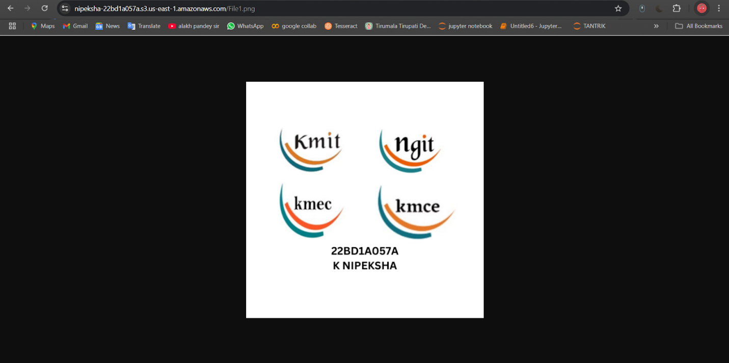

- End the Lab
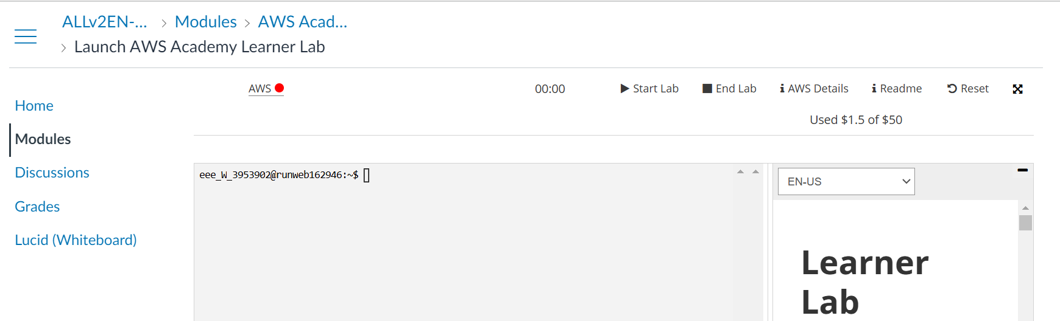

How S3 Maintains Versioning
- Each object has multiple versions instead of replacing files.
- That is saving all the files with the same name I saved it as File1.
- Every update creates a new version with a unique Version_Id.
- When an object is deleted, only a delete marker is added (files are still retrievable).
- Permanently deleting an object requires deleting all versions.
- If we delete the latest version of a file, the next latest one becomes the new latest now
If the Bucket is Deleted?
- Permanently deleting a bucket removes all its contents forever.
Deleted objects can be restored only if the bucket still exists and the specific version is available.

